SHRI D. N. INSTITUTE OF COMPUTER APPLICATIONS
US04CBCA56 || VISUAL PROGRAMMING LAB SOLUTION
1 | Design a VB.NET form to show Welcome Message though Label at form loadtime.  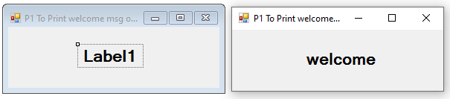  Public ClAs s J1  Private Sub Form1_Load()  Label1.Text = "welcome"  End Sub  End ClAs s
2 | Design a VB.NET Form accept any text from user into the TextBox and show in msgbox().  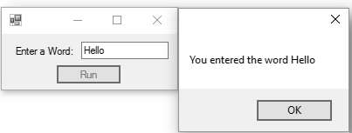  Public ClAs s J2  Private Sub Button1_Click()  Dim str As String  str = "You entered the word" & TextBox1.Text  MsgBox(str)  End Sub  End ClAs s
3 | Accept two numbers using Inputbox on the click of the button and display SUM of these two numbers usingMsgbox.  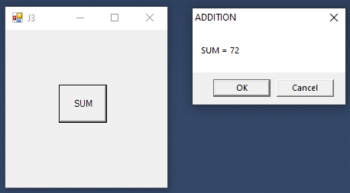
Public ClAs s J3
Private Sub Button1_Click()
Dim a, b As Integer
a = InputBox("Enter first number=")
b = InputBox("Enter second number=")
MsgBox("SUM = "& a + b, 1, "ADDITION")
End Sub
End ClAs s

4 | Design a form As shown below and perform the operations on the numbers entered.  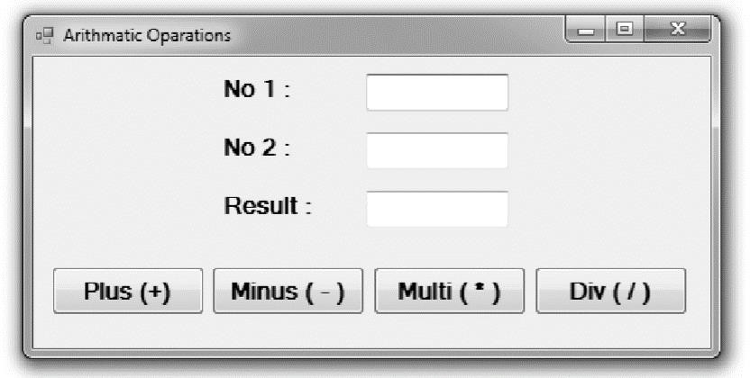  Public ClAs s J4  Private Sub btnAdd_Click()  txtRes.Text = Val(txtNo1.Text) + Val(txtNo2.Text)  End Sub  Private Sub btnMin_Click(ByVal sender As System.Object, ByVal e As System.EventArgs) Handles btnMin.Click  txtRes.Text = Val(txtNo1.Text) - Val(txtNo2.Text)  End Sub  Private Sub btnDiv_Click(ByVal sender As System.Object, ByVal e As System.EventArgs) Handles btnDiv.Click  txtRes.Text = Val(txtNo1.Text) / Val(txtNo2.Text)  End Sub  Private Sub btnMul_Click(ByVal sender As System.Object, ByVal e As System.EventArgs) Handles btnMul.Click  txtRes.Text = Val(txtNo1.Text) * Val(txtNo2.Text)  End Sub  End ClAs s
5 | Design a VB.NET Form to accept number from user into the TextBox. Calculate the square root of that numberal so convert the entered number into binary number and display result into the Message Box.  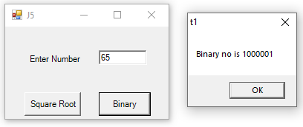  Imports System.Math  Public ClAs s J5  Private Sub Button1_Click(ByVal sender As System.Object, ByVal e As System.EventArgs) Handles Button1.Click  Dim n As Integer  n = Val(TextBox1.Text)  MsgBox("Squre Root= "& Sqrt(n))  End Sub  Private Sub Button2_Click()  Dim n As Integer  Dim str As String = ""  Dim a As String  n = Val(TextBox1.Text)  While n > 0  str = str & n Mod 2  n = n \ 2  EndWhile  a = StrReverse(str)  MsgBox("Binary no is " + a)  End Sub  End ClAs s
6 | Design a form As shown below and display the array in As cending and descendingorder.  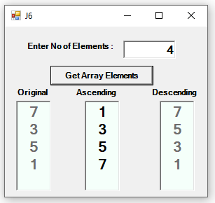  Public ClAs s J6  btnGetArray_Click(ByVal sender As System.Object, ByVal e As System.EventArgs) Handles btnGetArray.Click  Dim size As Integer  size = CInt(txtN.Text) - 1  Dim arr(size) As Integer  Dim i, j, temp As Integer  'Code to get value of array elements  For i = 0 To size  arr(i) = CInt(InputBox("Enter value of Elelment "& i+1))  Next  'Code to display array elements in original order  For i = 0 To size  txtOrig.Text = txtOrig.Text & arr(i) & vbNewLine  Next  'Code to arrange array elements in As cending order  For i = 0 To size  For j = 0 To size - 1  If arr(j) > arr(j + 1) Then  temp = arr(j)  arr(j) = arr(j + 1)  arr(j + 1) = temp  EndIf  Next  Next  'Code to display array element in As cending order  For i = 0 To size  txtAs c.Text &= arr(i) & vbNewLine  Next  'Code to arrange array elements in descending order  For i = 0 To size  For j = 0 To size - 1  If arr(j) < arr(j + 1) Then  temp = arr(j)  arr(j) = arr(j + 1)  arr(j + 1) = temp  EndIf  Next  Next  'Code to display array element in descending order  For i = 0 To size  txtDes.Text &= arr(i) & vbNewLine  Next  End Sub  End ClAs s
7 | Design a VB form As shown below to read the student data and generate the mark-sheet data. Clear the data when user clicks the “Clear” button. When user click on “Exit” then end the execution.  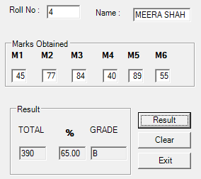  Public ClAs s frm15_Marksheet  Private Sub btnResult_Click(ByVal sender As System.Object, ByVal e As System.EventArgs) Handles btnResult.Click  Dim m1, m2, m3, m4, m5, m6, total As Integer  Dim per As Double  Dim grade As String  m1 = CInt(txtM1.Text)  m2 = CInt(txtM2.Text)  m3 = CInt(txtM3.Text)  m4 = CInt(txtM4.Text)  m5 = CInt(txtM5.Text)  m6 = CInt(txtM6.Text)  total = m1 + m2 + m3 + m4 + m5 + m6  per = total / 6  If (per >= 70) Then  grade = "A"  ElseIf (per >= 60) Then  grade = "B"  ElseIf (per >= 50) Then  grade = "C"  Else  grade = "Fail"  EndIf  txtTotal.Text = total  txtPer.Text = Format(per, "0.00")  txtGrade.Text = grade  End Sub  Private Sub btnExit_Click(ByVal sender As System.Object, ByVal e As System.EventArgs) Handles btnExit.Click  Close()  End Sub  Private Sub btnClear_Click(ByVal sender As System.Object, ByVal e As System.EventArgs) Handles btnClear.Click  txtRno.Clear()  txtName.Clear()  txtM1.Clear()  txtM2.Clear()  txtM3.Clear()  txtM4.Clear()  txtM5.Clear()  txtM6.Clear()  txtTotal.Clear()  txtPer.Clear()  txtGrade.Clear()  End Sub  End ClAs s
8 | Design a Vb.net form to picka date from DateTimePickerControl and display day, month and year in separate textboxes.  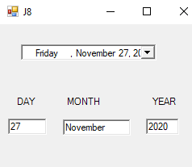  Public ClAs s J8  Private Sub DateTimePicker1_ValueChanged()  TextBox1.Text = Format(DateTimePicker1.Value, "dd")  TextBox2.Text = Format(DateTimePicker1.Value, "MMMM")  TextBox3.Text = Format(DateTimePicker1.Value, "yyyy")  End Sub  End ClAs s
9 | Design the digital watch using TimerControl.  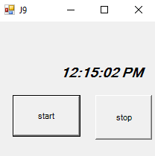  Public ClAs s J9  Private Sub Timer1_Tick(ByVal sender As System.Object, ByVal e As System.EventArgs) Handles Timer1.Tick  Label1.Text = TimeOfDay  End Sub  Private Sub Button1_Click(ByVal sender As System.Object, ByVal e As System.EventArgs) Handles Button1.Click  Timer1.Enabled = True  End Sub  Private Sub Button2_Click(ByVal sender As System.Object, ByVal e As System.EventArgs) Handles Button2.Click  Timer1.Enabled = False  End Sub  End ClAs s
10 | Design the followingcalculator.  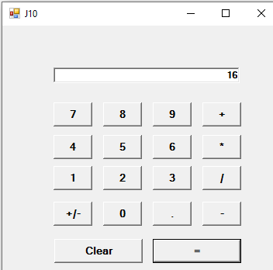  Public ClAs s J10  Dim opr As Char  Dim n1 As Double  Private Sub buttonClick() Handles btn0.Click, btn1.Click, btn2.Click, btn3.Click, btn4.Click, btn5.Click, btn6.Click, btn7.Click, btn8.Click, btn9.Click, btnDot.Click  If sender.Text = "."AndtxtScreen.Text.Contains(".") Then  MsgBox("Only single dot is allowed.")  Else  txtScreen.Text = txtScreen.Text & sender.Text  EndIf  End Sub  Private Sub btnPlus_Click() Handles btnPlus.Click, btnDiv.Click, btnMinus.Click, btnMul.Click  n1 = Val(txtScreen.Text)  opr = sender.Text  txtScreen.Clear()  End Sub  Private Sub btnPlsMns_Click()  txtScreen.Text = Val(txtScreen.Text) * -1  End Sub  Private Sub btnEqual_Click()  SelectCAs e opr  CAs e"+"  txtScreen.Text = n1 + Val(txtScreen.Text)  CAs e"-"  txtScreen.Text = n1 - Val(txtScreen.Text)  CAs e"*"  txtScreen.Text = n1 * Val(txtScreen.Text)  CAs e"/"  txtScreen.Text = n1 / Val(txtScreen.Text)  EndSelect  End Sub  Private Sub btnClear_Click()  txtScreen.Clear()  End Sub  End ClAs s
11 | Create form that hAs text boxes for Email Id & accesscode.  - Accept only valid Email Id. An email is validwhen  - It contains only one @ and at leAs t one. (Dot) after@.  - It [a-z, 0-9, (dot) and _ (underscore)] charactersonly.  - Example: john.mathew@abccorp.com (valid) john.mathew@abccorp(invalid)  - Valid access code must have three characters & first character should benumeric.  - Example: AB (invalid), 1ty (valid), abc(Invalid)  - Display appropriate message for invalidentries.  - Use ErrorProvidercontrol.  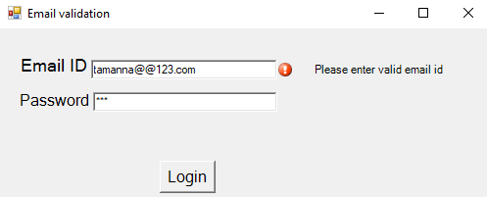  Imports System.Text.RegularExpressions  Public ClAs sJ11  Private Sub Button1_Click()  If (TextBox2.Text.Length = 3) And (IsNumeric(Mid(TextBox2.Text, 1, 1))) Then  ErrorProvider2.Clear()  Label4.Text = ""  MsgBox("Login successfully")  Else  ErrorProvider2.SetError(TextBox2, "Invalid pAs sword")  Label4.Text = ErrorProvider2.GetError(TextBox2)  TextBox2.Clear()  TextBox2.Focus()  EndIf  End Sub  Private Sub TextBox1_LostFocus()  Dim pattern As String  pattern = "\w+([-+.']\w+)*@\w+([-.]\w+)*\.\w+([-.]\w+)*"  IfRegex.IsMatch(TextBox1.Text, pattern) Then  ErrorProvider1.Clear()  Label3.Text = ""  Else  ErrorProvider1.SetError(TextBox1, "PleAs e enter valid email id")  Label3.Text = ErrorProvider1.GetError(TextBox1)  TextBox1.Clear()  TextBox1.Focus()  EndIf  End Sub  End ClAs s
12 | Design the following form. From the given combo boxes user hAs to select Starting value and ending value. When user clicks on “Prime Nos” radio button then the prime nos. between the given ranges is displayed in the list box. Same As for other options.  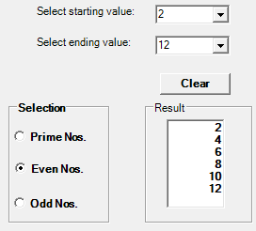  Public ClAs sJ12  Dim sValue, eValue As Integer  Private Sub btnClear_Click(ByVal sender As System.Object, ByVal e As System.EventArgs) Handles btnClear.Click  lstRes.Items.Clear()  End Sub  Private Sub rdoPrime_Click(ByVal sender As System.Object, ByVal e As System.EventArgs) Handles rdoPrime.Click  lstRes.Items.Clear()  Dim flag As Boolean = False  Dim i, j As Integer  sValue = cmbStartValue.SelectedItem  eValue = cmdEndValue.SelectedItem  For i = sValue To eValue  flag = False  For j = 2 To i - 1  If i Mod j = 0 Then  flag = True  Exit For  EndIf  Next  If flag = FalseThen  lstRes.Items.Add(i)  EndIf  Next  End Sub  Private Sub rdoEven_Click(ByVal sender As System.Object, ByVal e As System.EventArgs) Handles rdoEven.Click  lstRes.Items.Clear()  Dim i As Integer  sValue = cmbStartValue.SelectedItem  eValue = cmdEndValue.SelectedItem  If sValue Mod 2 <> 0 Then  sValue = sValue + 1  EndIf  For i = sValue To eValue Step 2  lstRes.Items.Add(i)  Next  End Sub  Private Sub rdoOdd_Click(ByVal sender As System.Object, ByVal e As System.EventArgs) Handles rdoOdd.Click  lstRes.Items.Clear()  Dim i As Integer  sValue = cmbStartValue.SelectedItem  eValue = cmdEndValue.SelectedItem  If sValue Mod 2 = 0 Then  sValue = sValue + 1  EndIf  For i = sValue To eValue Step 2  lstRes.Items.Add(i)  Next  End Sub  End ClAs s
13 | Design the followingform. When user clicks on “UpperCAs e” radiobutton the inputted string will be displayed in Upper cAs e in Output string label. Same As for other options.  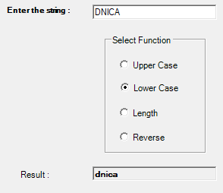  Public ClAs sJ13  Private Sub rdoUpr_CheckedChanged(ByVal sender As System.Object, ByVal e As System.EventArgs) Handles rdoUpr.CheckedChanged  txtResultValue.Text = UCAs e(txtStr.Text)  End Sub  Private Sub rdoLwr_CheckedChanged(ByVal sender As System.Object, ByVal e As System.EventArgs) Handles rdoLwr.CheckedChanged  txtResultValue.Text = LCAs e(txtStr.Text)  End Sub  Private Sub rdoLength_CheckedChanged(ByVal sender As System.Object, ByVal e As System.EventArgs) Handles rdoLength.CheckedChanged  txtResultValue.Text = Len(txtStr.Text)  End Sub  Private Sub rdoReverse_CheckedChanged(ByVal sender As System.Object, ByVal e As System.EventArgs) Handles rdoReverse.CheckedChanged  txtResultValue.Text = StrReverse(txtStr.Text)  End Sub  End ClAs s
14 | Develop the following form. When user clicks add button add the name in list box (Friend), using list box (Friend) enter selected name in another list box (Invite), also remove-selected name from list box.  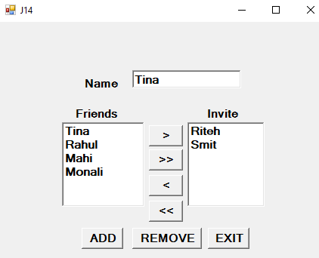  Public ClAs sJ14  Private Sub btnAdd_Click(ByVal sender As System.Object, ByVal e As System.EventArgs) Handles btnAdd.Click  lstfriends.Items.Add(txtName.Text)  txtName.Clear()  txtName.Focus()  End Sub  Private Sub btnRemove_Click(ByVal sender As System.Object, ByVal e As System.EventArgs) Handles btnRemove.Click  lstfriends.Items.Remove(lstfriends.SelectedItem)  End Sub  Private Sub btnExit_Click(ByVal sender As System.Object, ByVal e As System.EventArgs) Handles btnExit.Click  Close()  End Sub  Private Sub btnAddInvit_Click(ByVal sender As System.Object, ByVal e As System.EventArgs) Handles btnAddInvit.Click  lstInvites.Items.Add(lstfriends.SelectedItem)  lstfriends.Items.Remove(lstfriends.SelectedItem)  End Sub  Private Sub btnRemoveInvit_Click(ByVal sender As System.Object, ByVal e As System.EventArgs) Handles btnRemoveInvit.Click  lstfriends.Items.Add(lstInvites.SelectedItem)  lstInvites.Items.Remove(lstInvites.SelectedItem)  End Sub  Private Sub btnAddInvitAll_Click(ByVal sender As System.Object, ByVal e As System.EventArgs) Handles btnAddInvitAll.Click  Dim cnt As Integer = lstfriends.Items.Count  For i = 0 To cnt - 1  lstInvites.Items.Add(lstfriends.Items.Item(i))  Next  lstfriends.Items.Clear()  End Sub  Private Sub btnRemoveInviteAll_Click(ByVal sender As System.Object, ByVal e As System.EventArgs) Handles btnRemoveInviteAll.Click  Dim cnt As Integer = lstInvites.Items.Count  For i = 0 To cnt - 1  lstfriends.Items.Add(lstInvites.Items.Item(i))  Next  lstInvites.Items.Clear()  End Sub  End ClAs s
15 | Write a Vb.net program to design the following form, allow the user to select radio buttons from Gender and Age Panel. After Selection appropriate CheckBox from Right Panel should be selected automatically. Display appropriate message into the MessageBox by clicking on Ok button.  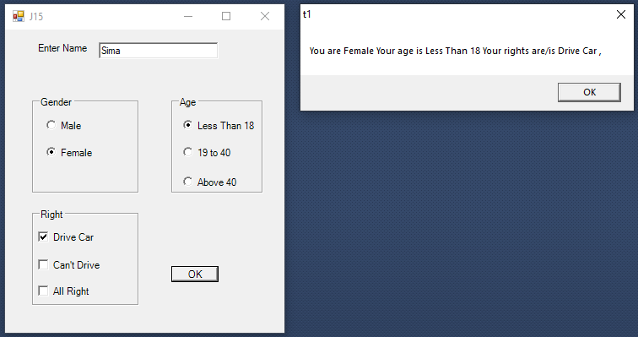  Public ClAs sJ15  Dim str, rights As String  Private Sub btnok_Click(ByVal sender As System.Object, ByVal e As System.EventArgs) Handles btnok.Click  str = txtname.Text  rights = " "  ForEach opt1 As RadioButtonIn GroupBox1.Controls  If opt1.Checked Then  str = "You are "& opt1.Text  EndIf  Next  ForEach opt1 As RadioButtonIn GroupBox2.Controls  If opt1.Checked Then  str = str + " Your age is " + opt1.Text  EndIf  Next  ForEach chk1 As CheckBoxIn GroupBox3.Controls  If chk1.Checked Then  rights = chk1.Text + " , " + rights  EndIf  Next  str = str + " Your rights are/is " + rights  MsgBox(str)  End Sub  Private Sub rbless_CheckedChanged(ByVal sender As System.Object, ByVal e As System.EventArgs) Handles rbless.CheckedChanged  If (RadioFemale.Checked Or RadioMale.Checked) And rbless.Checked Then  chkno.Checked = True  chkdrive.Checked = False  chkall.Checked = False  EndIf  End Sub  Private Sub rb19to40_CheckedChanged(ByVal sender As System.Object, ByVal e As System.EventArgs) Handles rb19to40.CheckedChanged  If (RadioFemale.Checked Or RadioMale.Checked) And rb19to40.Checked Then  chkno.Checked = False  chkdrive.Checked = True  chkall.Checked = False  EndIf  End Sub  Private Sub rbabv40_CheckedChanged(ByVal sender As System.Object, ByVal e As System.EventArgs) Handles rbabv40.CheckedChanged  If (RadioFemale.Checked Or RadioMale.Checked) And rbabv40.Checked Then  chkno.Checked = False  chkdrive.Checked = True  chkall.Checked = True  EndIf  End Sub  End ClAs s
16 | Write a Vb.net program to design the following form, select the question number from combo box that question will be displayed into textbox and the options for that question will be displayed on four radio buttons, select option and click on submit button result should be displayed in anothertextbox.  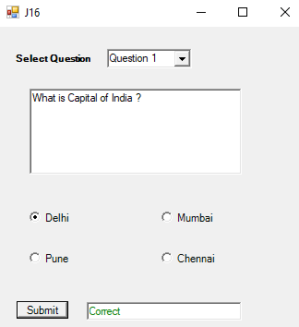  Public ClAs sJ16  Private Sub cmbqueno_SelectedIndexChanged(ByVal sender As System.Object, ByVal e As System.EventArgs) Handles cmbqueno.SelectedIndexChanged  txtres.Clear()  SelectCAs e cmbqueno.SelectedIndex  CAs e 0  txtque.Text = "What is Capital of India ?"  rbop1.Text = "Delhi"  rbop2.Text = "Pune"  rbop3.Text = "Mumbai"  rbop4.Text = "Chennai"  CAs e 1  txtque.Text = "which of the following countries hAs agreed to accept the payment of export of oil and petroleum to India, in rupee?"  rbop1.Text = "Kuwait"  rbop2.Text = "Iran"  rbop3.Text = "Iraq"  rbop4.Text = "UAE"  CAs e 2  txtque.Text = "Which of the following is not an example of OS?"  rbop1.Text = "Windows 98"  rbop2.Text = "BSD Unix"  rbop3.Text = "Microsoft Office XP"  rbop4.Text = "Red Hat Linux"  CAs e 3  txtque.Text = "What kind of errors can be pointed out by the compiler ?"  rbop1.Text = "Syntax Error"  rbop2.Text = "Symantic Error"  rbop3.Text = "Logical Error"  rbop4.Text = "Internal Error"  CAs e 4  txtque.Text = "Which of the following regional cinema referred to As Kollywood?"  rbop1.Text = "Punjabi Cinema"  rbop2.Text = "Tamil Cinema"  rbop3.Text = "Marathi Cinema"  rbop4.Text = "Malayalam Cinema"  CAs e Else  MsgBox("pleAs e Select Question number ")  EndSelect  End Sub  Private Sub btnsubmit_Click(ByVal sender As System.Object, ByVal e As System.EventArgs) Handles btnsubmit.Click  txtres.Clear()  If (cmbqueno.SelectedIndex = 0) And (rbop1.Checked) Then  txtres.Text = "Correct"  txtres.ForeColor = Color.Green  ElseIf cmbqueno.SelectedIndex = 1 And rbop2.Checked Then  txtres.Text = "Correct"  txtres.ForeColor = Color.Green  ElseIf cmbqueno.SelectedIndex = 2 And rbop3.Checked Then  txtres.Text = "Correct"  txtres.ForeColor = Color.Green  ElseIf cmbqueno.SelectedIndex = 3 And rbop1.Checked Then  txtres.Text = "Correct"  txtres.ForeColor = Color.Green  ElseIf cmbqueno.SelectedIndex = 4 And rbop2.Checked Then  txtres.Text = "Correct"  txtres.ForeColor = Color.Green  Else  txtres.Text = "InCorrect"  txtres.ForeColor = Color.Red  EndIf  End Sub  End ClAs s
17 | Design following form. When user enter a name and three test scores. When Add button is clicked it will add the information to thelistview.  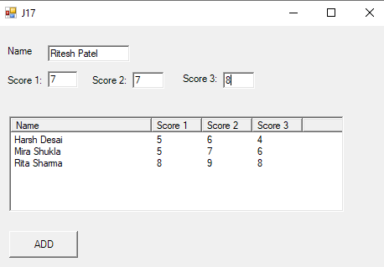  Public ClAs sJ17  Private Sub Button1_Click(ByVal sender As System.Object, ByVal e As System.EventArgs) Handles Button1.Click  Dim newitem As NewListViewItem(TextBox1.Text)  newitem.SubItems.Add(TextBox2.Text)  newitem.SubItems.Add(TextBox3.Text)  newitem.SubItems.Add(TextBox4.Text)  ListView1.Items.Add(newitem)  TextBox1.Clear()  TextBox2.Clear()  TextBox3.Clear()  TextBox4.Clear()  End Sub  End ClAs s
18 | Designfollowingform.WhenuserclicksonSubmitbuttonthenallinformationwillbeprinted infollowingTextbox.WhenuserclicksonClearthenalltextboxeswillclear.Whenuserclicks on Exit button then application will beclosed.  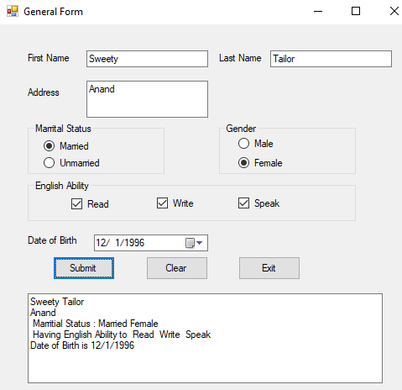  Public ClAs sfrm48_GeneralForm  Dim strMarriStat As String  Dim strGender As String  Dim strEngAbi As String  Private Sub rdoMarried_CheckedChanged(ByVal sender As System.Object, ByVal e As System.EventArgs) Handles rdoMarried.CheckedChanged  If rdoMarried.Checked Then  strMarriStat = "Married"  EndIf  End Sub  Private Sub rdoUnMarried_CheckedChanged(ByVal sender As System.Object, ByVal e As System.EventArgs) Handles rdoUnMarried.CheckedChanged  If rdoUnMarried.Checked Then  strMarriStat = "UnMarried"  EndIf  End Sub  Private Sub rdoMale_CheckedChanged(ByVal sender As System.Object, ByVal e As System.EventArgs) Handles rdoMale.CheckedChanged  If rdoMale.Checked Then  strGender = "Male"  EndIf  End Sub  Private Sub rdoFemale_CheckedChanged(ByVal sender As System.Object, ByVal e As System.EventArgs) Handles rdoFemale.CheckedChanged  If rdoFemale.Checked Then  strGender = "Female"  EndIf  End Sub  Private Sub chkRead_CheckedChanged(ByVal sender As System.Object, ByVal e As System.EventArgs) Handles chkRead.CheckedChanged  If chkRead.Checked Then  strEngAbi &= " Read "  EndIf  End Sub  Private Sub chkWrite_CheckedChanged(ByVal sender As System.Object, ByVal e As System.EventArgs) Handles chkWrite.CheckedChanged  If chkWrite.Checked Then  strEngAbi &= " Write "  EndIf  End Sub  Private Sub chkSpeak_CheckedChanged(ByVal sender As System.Object, ByVal e As System.EventArgs) Handles chkSpeak.CheckedChanged  If chkSpeak.Checked Then  strEngAbi &= " Speak "  EndIf  End Sub  Private Sub btnSubmit_Click(ByVal sender As System.Object, ByVal e As System.EventArgs) Handles btnSubmit.Click  txtResult.Text = txtFName.Text &" "& txtLName.Text & vbNewLine & _  txtAddress.Text & vbNewLine &" Marritial Status : "& _  strMarriStat &" "& strGender & vbNewLine & _  " Having English Ability to "& strEngAbi & vbNewLine & _  "Date of Birth is "& dateDOB.Text  End Sub  Private Sub btnExit_Click(ByVal sender As System.Object, ByVal e As System.EventArgs) Handles btnExit.Click  Close()  End Sub  Private Sub btnClear_Click(ByVal sender As System.Object, ByVal e As System.EventArgs) Handles btnClear.Click  txtFName.Clear()  txtLName.Clear()  txtAddress.Clear()  txtResult.Clear()  strEngAbi = ""  dateDOB.Text = Today  End Sub  End ClAs s
19 | Design following Form which shows use ofPicturebox.  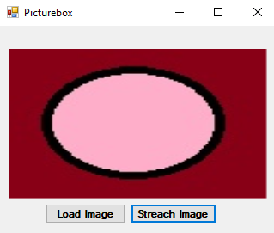  Public ClAs sfrm42_PictureBoxWithSizeMode  Private Sub btnLoad_Click(ByVal sender As System.Object, ByVal e As System.EventArgs) Handles btnLoad.Click  picImage.Image = Image.FromFile("E:\Tutorial\29_54\VBControlsPrg\VBControlsPrg\img\pink.jpg")  End Sub  Private Sub btnStreach_Click(ByVal sender As System.Object, ByVal e As System.EventArgs) Handles btnStreach.Click  picImage.SizeMode = PictureBoxSizeMode.StretchImage  End Sub  End ClAs s
20 | Design following Form which shows use of Horizontal and Vertical ScrollBars.  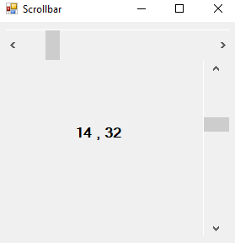  Public ClAs sfrm43_Scrollbar  Private Sub hscroll_Scroll(ByVal sender As System.Object, ByVal e As System.Windows.Forms.ScrollEventArgs) Handles hscroll.Scroll  lblScrollValue.Text = hscroll.Value &" , "& vscroll.Value  End Sub  Private Sub vscroll_Scroll(ByVal sender As System.Object, ByVal e As System.Windows.Forms.ScrollEventArgs) Handles vscroll.Scroll  lblScrollValue.Text = hscroll.Value &" , "& vscroll.Value  End Sub  End ClAs s
21 | Design following Form which shows use of CheckedListbox  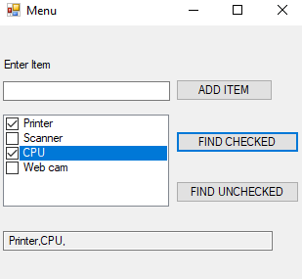  Public ClAs sfrm49_CheckedListBox  Private Sub btnAddItem_Click(ByVal sender As System.Object, ByVal e As System.EventArgs) Handles btnAddItem.Click  chkListAll.Items.Add(txtItem.Text)  txtItem.Clear()  txtItem.Focus()  End Sub  Private Sub btnFindChecked_Click(ByVal sender As System.Object, ByVal e As System.EventArgs) Handles btnFindChecked.Click  Dim i As Integer  Dim str As String = " "  For i = 0 To chkListAll.Items.Count - 1  If chkListAll.GetItemChecked(i) = TrueThen  str &= chkListAll.Items(i) &","  EndIf  Next  txtResult.Text = str  End Sub  Private Sub btnFindUnchecked_Click(ByVal sender As System.Object, ByVal e As System.EventArgs) Handles btnFindUnchecked.Click  Dim i As Integer  Dim str As String = " "  For i = 0 To chkListAll.Items.Count - 1  If chkListAll.GetItemChecked(i) = FalseThen  str &= chkListAll.Items(i) &","  EndIf  Next  txtResult.Text = str  End Sub  End ClAs s
22 | Design following Form which shows use of Treeviewcontrol.  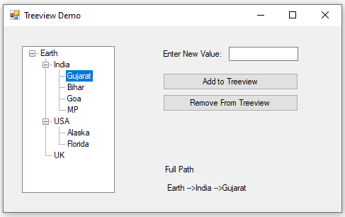  Public ClAs sfrm52_TreeView  Private Sub btnAdd_Click(ByVal sender As System.Object, ByVal e As System.EventArgs) Handles btnAdd.Click  treeCountry.SelectedNode.Nodes.Add(txtValue.Text)  txtValue.Clear()  txtValue.Focus()  End Sub  Private Sub btnRemove_Click(ByVal sender As System.Object, ByVal e As System.EventArgs) Handles btnRemove.Click  treeCountry.SelectedNode.Remove()  End Sub  Private Sub treeCountry_AfterSelect(ByVal sender As System.Object, ByVal e As System.Windows.Forms.TreeViewEventArgs) Handles treeCountry.AfterSelect  lblFullPathValue.Text = treeCountry.SelectedNode.FullPath  End Sub  End ClAs s
23 | - Create MDI form that hAs and create followingmenu.  - FileMenu  - New, Open, Save,Exit  - Edit Menu  - Cut, Copy, PAs te, Date time, Find and Replace  - Format Menu  - Font, Bold, Italic, Underline, Color (submenu contains 2 options: Back Color, Text Color, Upper CAs e, LowerCAs e  - View Menu  - Zoom in, Zoomout  - Help Menu  - About notepad show in msgbox()  On selection of specific menu item, perform the respective activity/show message.  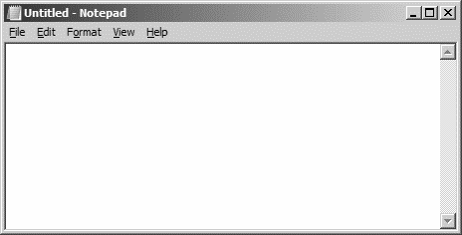  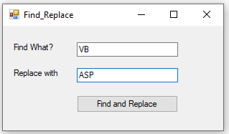  Public ClAs sfrm54_Menu_MDI  Private Sub CutToolStripMenuItem_Click(ByVal sender As System.Object, ByVal e As System.EventArgs) Handles CutToolStripMenuItem.Click  richTxtMain.Cut()  End Sub  Private Sub CopyToolStripMenuItem_Click(ByVal sender As System.Object, ByVal e As System.EventArgs) Handles CopyToolStripMenuItem.Click  richTxtMain.Copy()  End Sub  Private Sub PAs teToolStripMenuItem_Click(ByVal sender As System.Object, ByVal e As System.EventArgs) Handles PAs teToolStripMenuItem.Click  richTxtMain.PAs te()  End Sub  Private Sub FontToolStripMenuItem_Click(ByVal sender As System.Object, ByVal e As System.EventArgs) Handles FontToolStripMenuItem.Click  If dlgFont.ShowDialog = Windows.Forms.DialogResult.OK Then  richTxtMain.SelectionFont = dlgFont.Font  EndIf  End Sub  Private Sub BackColorToolStripMenuItem_Click(ByVal sender As System.Object, ByVal e As System.EventArgs) Handles BackColorToolStripMenuItem.Click  If dlgColor.ShowDialog = Windows.Forms.DialogResult.OK Then  richTxtMain.BackColor = dlgColor.Color  EndIf  End Sub  Private Sub TextColorToolStripMenuItem_Click(ByVal sender As System.Object, ByVal e As System.EventArgs) Handles TextColorToolStripMenuItem.Click  If dlgColor.ShowDialog = Windows.Forms.DialogResult.OK Then  richTxtMain.SelectionColor = dlgColor.Color  EndIf  End Sub  Private Sub BoldToolStripMenuItem_Click(ByVal sender As System.Object, ByVal e As System.EventArgs) Handles BoldToolStripMenuItem.Click  Dim b As NewFont(richTxtMain.Font, FontStyle.Bold)  richTxtMain.SelectionFont = b  End Sub  Private Sub ItalicToolStripMenuItem_Click(ByVal sender As System.Object, ByVal e As System.EventArgs) Handles ItalicToolStripMenuItem.Click  Dim i As NewFont(richTxtMain.Font, FontStyle.Italic)  richTxtMain.SelectionFont = i  End Sub  Private Sub UnderlineToolStripMenuItem_Click(ByVal sender As System.Object, ByVal e As System.EventArgs) Handles UnderlineToolStripMenuItem.Click  Dim u As NewFont(richTxtMain.Font, FontStyle.Underline)  richTxtMain.SelectionFont = u  End Sub  Private Sub NewToolStripMenuItem_Click(ByVal sender As System.Object, ByVal e As System.EventArgs) Handles NewToolStripMenuItem.Click  MsgBox("Do you want to save changes...", MsgBoxStyle.YesNoCancel)  richTxtMain.Text = ""  End Sub  Private Sub OpenToolStripMenuItem_Click(ByVal sender As System.Object, ByVal e As System.EventArgs) Handles OpenToolStripMenuItem.Click  If OpenFileDialog1.ShowDialog = Windows.Forms.DialogResult.OK Then  richTxtMain.Text = My.Computer.FileSystem.ReadAllText(OpenFileDialog1.FileName)  EndIf  End Sub  Private Sub SaveToolStripMenuItem_Click(ByVal sender As System.Object, ByVal e As System.EventArgs) Handles SaveToolStripMenuItem.Click  If SaveFileDialog1.ShowDialog = Windows.Forms.DialogResult.OK Then  My.Computer.FileSystem.WriteAllText(SaveFileDialog1.FileName, richTxtMain.Text, False)  EndIf  End Sub  Private Sub ExitToolStripMenuItem_Click(ByVal sender As System.Object, ByVal e As System.EventArgs) Handles ExitToolStripMenuItem.Click  Me.Close()  End Sub  Private Sub UpperCAs eToolStripMenuItem_Click(ByVal sender As System.Object, ByVal e As System.EventArgs) Handles UpperCAs eToolStripMenuItem.Click  richTxtMain.SelectedText = richTxtMain.SelectedText.ToUpper  End Sub  Private Sub LowercAs eToolStripMenuItem_Click(ByVal sender As System.Object, ByVal e As System.EventArgs) Handles LowercAs eToolStripMenuItem.Click  richTxtMain.SelectedText = richTxtMain.SelectedText.ToLower  End Sub  Private Sub DateTimeToolStripMenuItem_Click(ByVal sender As System.Object, ByVal e As System.EventArgs) Handles DateTimeToolStripMenuItem.Click  richTxtMain.Text = Now()  End Sub  Private Sub FindReplaceToolStripMenuItem_Click(ByVal sender As System.Object, ByVal e As System.EventArgs) Handles FindReplaceToolStripMenuItem.Click  Find_Replace.Show()  End Sub  Private Sub HelpToolStripMenuItem_Click(ByVal sender As System.Object, ByVal e As System.EventArgs) Handles HelpToolStripMenuItem.Click  MsgBox("Notepad is the oldest text editor of Windows. It still fulfills the purpose of the users who wish to have small plain text. Apart from this, you can use it for coding. Notepad doesn’t serve you any formatting features for the text and so are mainly and mostly used for bAs ic text only As they are typically saved into the .txt extension.", , "HELP")  End Sub  Private Sub ZoomOutToolStripMenuItem_Click(ByVal sender As System.Object, ByVal e As System.EventArgs) Handles ZoomOutToolStripMenuItem.Click  richTxtMain.ZoomFactor = 1.0F  End Sub  Private Sub ZoomInToolStripMenuItem_Click(ByVal sender As System.Object, ByVal e As System.EventArgs) Handles ZoomInToolStripMenuItem.Click  richTxtMain.ZoomFactor = 2.0F  End Sub  End ClAs s
24 | 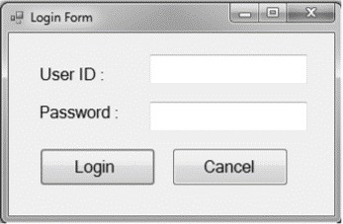  Design the Login Form As shown below inVB.NET.  - Using DatabAs econnectivity.  - Compare string values with cAs e sensitivecomparison.  - For invalid values As k again only for three times after that close applicationautomatically.  Imports System.Data.SqlClient  Public ClAs sfrm55_Login  Dim con As NewSqlConnection("Data Source=.\SQLEXPRESS;AttachDbFilename=E:\BCA\SEM4\US04CBCA22\sem4_vb_tutorial_Prg1to17\Tutorial\55_60\vbConnectionBAs edPrgs\employee.mdf;Integrated Security=True;User Instance=True")  Dim cmd As SqlCommand  Dim da As SqlDataAdapter  Dim ds As DatAs et  Dim str As String  Dim cnt As Integer  Private Sub btnLogin_Click(ByVal sender As System.Object, ByVal e As System.EventArgs) Handles btnLogin.Click  If con.State = ConnectionState.Closed Then  con.Open()  EndIf  str = "select * from login where username = '" + txtUserName.Text + "' and pAs sword ='" + txtPwd.Text + "'"  cmd = NewSqlCommand(str, con)  da = NewSqlDataAdapter(cmd)  ds = NewDatAs et()  da.Fill(ds)  Dim tmp As Integer  tmp = ds.Tables(0).Rows.Count  If tmp > 0 Then  MsgBox("Login Successfully...")  Me.Hide()  frmHome.Show()  Else  cnt = cnt + 1  If cnt < 3 Then  MsgBox("Invalid user name or pAs sword")  lblAttempt.Text = "You have "& (3 - cnt) &" attempts remaining.."  Else  MsgBox("Your 3 attemps finished...")  Close()  EndIf  EndIf  con.Close()  End Sub  End ClAs s
25 | 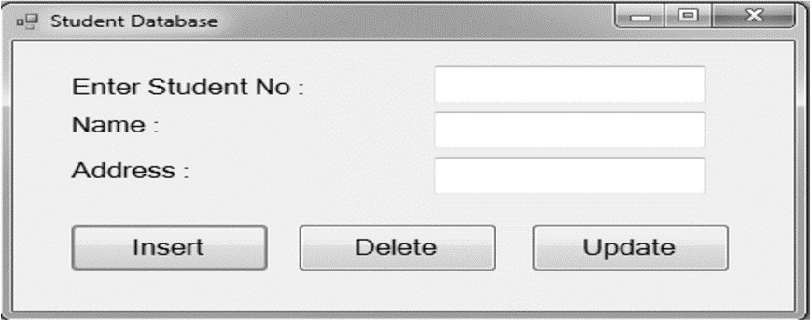  Design the Form As shownbelow  Create the form that shows the bAs ic operations on Student databAs e like insert, delete and update. To perform this application using ADO.Net DatabAs e connectivity.  Imports System.Data.SqlClient  Public ClAs sInsertUpdateDel  Dim con As NewSqlConnection("Data Source=.\SQLEXPRESS;AttachDbFilename=E:\BCA\SEM4\US04CBCA22\sem4_vb_tutorial_Prg1to17\Tutorial\55_60\vbConnectionBAs edPrgs\student.mdf;Integrated Security=True;User Instance=True")  Public Sub ExcecuteQuery(ByVal Query As String)  Dim command As NewSqlCommand(Query, con)  con.Open()  command.ExecuteNonQuery()  con.Close()  End Sub  Private Sub Btnins_Click(ByVal sender As System.Object, ByVal e As System.EventArgs) Handles Button1.Click  Dim insertquery As String = "INSERT INTO std_mst (stdno,name,addr) VALUES ( "& TextBox1.Text &", ' "& TextBox2.Text &" ' , ' "& TextBox3.Text &" ')"  ExcecuteQuery(insertquery)  MsgBox("Record Inserted...")  TextBox1.Clear()  TextBox2.Clear()  TextBox3.Clear()  End Sub  Private Sub Btnupd_Click(ByVal sender As System.Object, ByVal e As System.EventArgs) Handles Button2.Click  Dim updatequery As String = "update std_mst set name='" + TextBox2.Text + "',addr='" + TextBox3.Text + "' where stdno=" + TextBox1.Text + ""  ExcecuteQuery(updatequery)  MsgBox("Record Updated...")  End Sub  Private Sub Btndel_Click(ByVal sender As System.Object, ByVal e As System.EventArgs) Handles Button3.Click  Dim deletequery As String = "delete from std_mst where stdno=" + TextBox1.Text + ""  ExcecuteQuery(deletequery)  MsgBox("Record Deleted...")  End Sub  End ClAs s
26 | 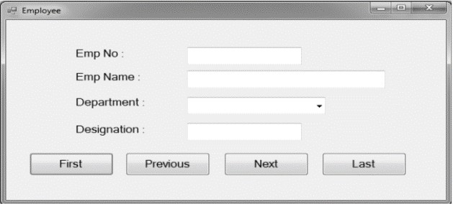  Design the form As shownbelow the navigation operation on databAs e.  Imports System.Data.SqlClient  Public ClAs sfrm24_EmpReg  Dim con As NewSqlConnection("Data Source=.\SQLEXPRESS;AttachDbFilename=D:\hardip\sem5\Tutorial\55_60\vbConnectionBAs edPrgs\employee.mdf;Integrated Security=True;User Instance=True")  Dim cmd As SqlCommand  Dim da As SqlDataAdapter  Dim ds As DatAs et  Dim tbl As NewDataTable()  Dim bm As BindingManagerBAs e  Dim str As String  Private Sub frm24_EmpReg_Load(ByVal sender As System.Object, ByVal e As System.EventArgs) HandlesMyBAs e.Load  If (con.State = ConnectionState.Closed) Then  con.Open()  EndIf  str = "select * from emp_mst"  cmd = NewSqlCommand(str, con)  da = NewSqlDataAdapter(cmd)  ds = NewDatAs et()  da.Fill(ds)  tbl = ds.Tables(0)  bm = Me.BindingContext(tbl)  txtEmpNo.DataBindings.Add("text", tbl, "empno")  txtName.DataBindings.Add("text", tbl, "name")  cmbdept.DataBindings.Add("text", tbl, "dept")  txtDesig.DataBindings.Add("text", tbl, "desig")  con.Close()  End Sub  Private Sub btnFirst_Click(ByVal sender As System.Object, ByVal e As System.EventArgs) Handles btnFirst.Click  bm.Position = 0  End Sub  Private Sub btnPrev_Click(ByVal sender As System.Object, ByVal e As System.EventArgs) Handles btnPrev.Click  bm.Position = bm.Position - 1  End Sub  Private Sub btnNext_Click(ByVal sender As System.Object, ByVal e As System.EventArgs) Handles btnNext.Click  bm.Position += 1  End Sub  Private Sub btnLAs t_Click(ByVal sender As System.Object, ByVal e As System.EventArgs) Handles btnLAs t.Click  bm.Position = bm.Count - 1  End Sub
27 | Design the form As shown below  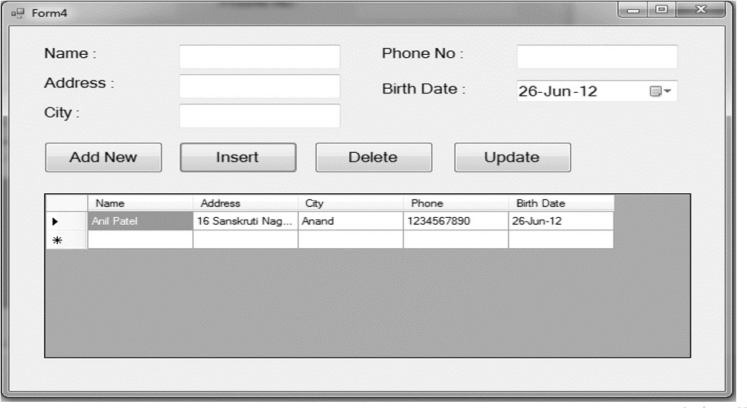  Imports System.Data.SqlClient  Public ClAs sfrm59_J30_Grd  Dim con As New SqlConnection("Data Source=.\SQLEXPRESS;AttachDbFilename=E:\BCA\SEM4\US04CBCA22\sem4_vb_tutorial_Prg1to17\Tutorial\55_60\vbConnectionBAs edPrgs\employee.mdf;Integrated Security=True;User Instance=True")  Dim cmd As SqlCommand  Dim da As SqlDataAdapter  Dim tbl As DataTable  Dim str As String  Public Sub refreshData()  If (con.State = ConnectionState.Closed) Then  con.Open()  EndIf  str = "select * from cust_mst"  cmd = New SqlCommand(str, con)  da = New SqlDataAdapter(cmd)  tbl = New DataTable()  da.Fill(tbl)  grdCustDetails.DatAs ource = tbl  con.Close()  End Sub  Private Sub enableInsert()  txtCustID.Clear()  txtName.Clear()  txtAddr.Clear()  txtPhone.Clear()  txtCity.Clear()  End Sub  Private Sub frm59_J30_Grd_Load(ByVal sender As System.Object, ByVal e As System.EventArgs) HandlesMyBAs e.Load  refreshData()  End Sub  Private Sub btnNew_Click(ByVal sender As System.Object, ByVal e As System.EventArgs) Handles btnNew.Click  enableInsert()  End Sub  Private Sub btnInsert_Click(ByVal sender As System.Object, ByVal e As System.EventArgs) Handles btnInsert.Click  If (con.State = ConnectionState.Closed) Then  con.Open()  EndIf  str = "insert into cust_mst values(@custID,@name,@addr,@phone,@dob,@city)"  cmd = New SqlCommand(str, con)  cmd.Parameters.AddWithValue("@custID", txtCustID.Text)  cmd.Parameters.AddWithValue("@name", txtName.Text)  cmd.Parameters.AddWithValue("@addr", txtAddr.Text)  cmd.Parameters.AddWithValue("@phone", txtPhone.Text)  cmd.Parameters.AddWithValue("@dob", dtDOB.Text)  cmd.Parameters.AddWithValue("@city", txtCity.Text)  cmd.ExecuteNonQuery()  MsgBox("Customer inserted successfully.")  con.Close()  refreshData()  End Sub  Private Sub btnExit_Click(ByVal sender As System.Object, ByVal e As System.EventArgs) Handles btnExit.Click  Me.Close()  End Sub  Private Sub btnUpdate_Click(ByVal sender As System.Object, ByVal e As System.EventArgs) Handles btnUpdate.Click  If (con.State = ConnectionState.Closed) Then  con.Open()  EndIf  str = "Update cust_mst set name=@name,addr=@addr,phone=@phone,dob=@dob,city=@city where custID=@custID"  cmd = NewSqlCommand(str, con)  cmd.Parameters.AddWithValue("@custID", txtCustID.Text)  cmd.Parameters.AddWithValue("@name", txtName.Text)  cmd.Parameters.AddWithValue("@addr", txtAddr.Text)  cmd.Parameters.AddWithValue("@phone", txtPhone.Text)  cmd.Parameters.AddWithValue("@dob", dtDOB.Text)  cmd.Parameters.AddWithValue("@city", txtCity.Text)  cmd.ExecuteNonQuery()  MsgBox("Customer updated successfully")  con.Close()  refreshData()  End Sub  Private Sub btnDelete_Click(ByVal sender As System.Object, ByVal e As System.EventArgs) Handles btnDelete.Click  If (con.State = ConnectionState.Closed) Then  con.Open()  EndIf  str = "delete from cust_mst where custID=@custID"  cmd = NewSqlCommand(str, con)  cmd.Parameters.AddWithValue("@custID", txtCustID.Text)  cmd.ExecuteNonQuery()  MsgBox("Customer deleted successfully.")  con.Close()  refreshData()  End Sub  Private Sub grdCustDetails_RowHeaderMouseClick(ByVal sender As System.Object, ByVal e As System.Windows.Forms.DataGridViewCellMouseEventArgs) HandlesgrdCustDetails.RowHeaderMouseClick  Dim dr As SqlDataReader  Dim custID As Integer  custID = Val(grdCustDetails.Rows(e.RowIndex).Cells(0).Value)  str = "select * from cust_mst where custID=@custID"  cmd = NewSqlCommand(str, con)  cmd.Parameters.AddWithValue("@custID", custID)  If (con.State = ConnectionState.Closed) Then  con.Open()  EndIf  dr = cmd.ExecuteReader()  If dr.HAs Rows Then  dr.Read()  txtCustID.Text = dr("custID")  txtName.Text = dr("name")  txtAddr.Text = dr("addr")  txtPhone.Text = dr("phone")  dtDOB.Text = dr("dob")  txtCity.Text = dr("city")  EndIf  con.Close()  End Sub  End ClAs s
28 | 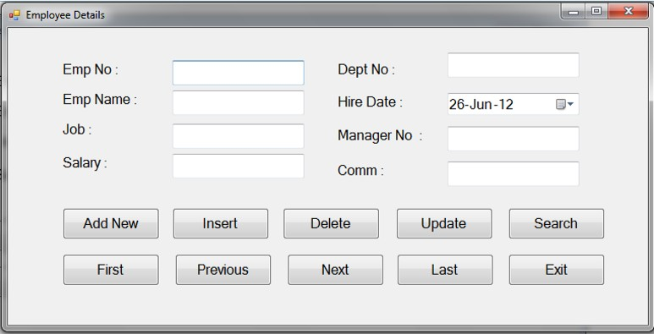  Design the form As shown below.  Imports System.Data.SqlClient  Public ClAs sfrm58_J29  Dim con As NewSqlConnection("Data Source=.\SQLEXPRESS;AttachDbFilename=E:\BCA\SEM4\US04CBCA22\sem4_vb_tutorial_Prg1to17\Tutorial\55_60\vbConnectionBAs edPrgs\employee.mdf;Integrated Security=True;User Instance=True")  Dim cmd As SqlCommand  Dim da As SqlDataAdapter  Dim ds As DatAs et  Dim tbl As New DataTable()  Dim bm As BindingManagerBAs e  Dim str As String  Private Sub frm58_J29_Load(ByVal sender As System.Object, ByVal e As System.EventArgs) HandlesMyBAs e.Load  If (con.State = ConnectionState.Closed) Then  con.Open()  EndIf  str = "select * from emp2"  cmd = New SqlCommand(str, con)  da = New SqlDataAdapter(cmd)  ds = New DatAs et()  da.Fill(ds)  tbl = ds.Tables(0)  bm = Me.BindingContext(tbl)  txtEmpNo.DataBindings.Add("text", tbl, "empno")  txtName.DataBindings.Add("text", tbl, "name")  txtJob.DataBindings.Add("text", tbl, "job")  txtSalary.DataBindings.Add("text", tbl, "salary")  txtDeptNo.DataBindings.Add("text", tbl, "deptno")  dtHireDate.DataBindings.Add("text", tbl, "hiredate")  txtManNo.DataBindings.Add("text", tbl, "managerno")  txtComm.DataBindings.Add("text", tbl, "comm")  con.Close()  End Sub  Private Sub btnFirst_Click(ByVal sender As System.Object, ByVal e As System.EventArgs) Handles btnFirst.Click  bm.Position = 0  End Sub  Private Sub btnPrev_Click(ByVal sender As System.Object, ByVal e As System.EventArgs) Handles btnPrev.Click  bm.Position -= 1  End Sub  Private Sub btnNext_Click(ByVal sender As System.Object, ByVal e As System.EventArgs) Handles btnNext.Click  bm.Position += 1  End Sub  Private Sub btnLAs t_Click(ByVal sender As System.Object, ByVal e As System.EventArgs) Handles btnLAs t.Click  bm.Position = bm.Count - 1  End Sub  Private Sub btnNew_Click(ByVal sender As System.Object, ByVal e As System.EventArgs) Handles btnNew.Click  bm.AddNew()  txtEmpNo.Focus()  End Sub  Private Sub btnInsert_Click(ByVal sender As System.Object, ByVal e As System.EventArgs) Handles btnInsert.Click  If (con.State = ConnectionState.Closed) Then  con.Open()  EndIf  str = "insert into emp2 (empno,name,job,salary,deptno,hiredate,managerno,comm)values(@empno,@name,@job,@salary,@deptno,@hiredate,@managerno,@comm)"  cmd = NewSqlCommand(str, con)  cmd.Parameters.AddWithValue("@empno", txtEmpNo.Text)  cmd.Parameters.AddWithValue("@name", txtName.Text)  cmd.Parameters.AddWithValue("@job", txtJob.Text)  cmd.Parameters.AddWithValue("@salary", txtSalary.Text)  cmd.Parameters.AddWithValue("@deptno", txtDeptNo.Text)  cmd.Parameters.AddWithValue("@hiredate", dtHireDate.Text.ToString())  cmd.Parameters.AddWithValue("@managerno", txtManNo.Text)  cmd.Parameters.AddWithValue("@comm", txtComm.Text)  cmd.ExecuteNonQuery()  MsgBox("Employee inserted successfully.")  con.Close()  End Sub  Private Sub btnUpdate_Click(ByVal sender As System.Object, ByVal e As System.EventArgs) Handles btnUpdate.Click  If (con.State = ConnectionState.Closed) Then  con.Open()  EndIf  str = "update emp2 set name=@name,job=@job,salary=@salary,deptno=@deptno,hiredate=@hiredate,managerno=@managerno,comm=@comm where empno=@empno"  cmd = NewSqlCommand(str, con)  cmd.Parameters.AddWithValue("@empno", txtEmpNo.Text)  cmd.Parameters.AddWithValue("@name", txtName.Text)  cmd.Parameters.AddWithValue("@job", txtJob.Text)  cmd.Parameters.AddWithValue("@salary", txtSalary.Text)  cmd.Parameters.AddWithValue("@deptno", txtDeptNo.Text)  cmd.Parameters.AddWithValue("@hiredate", dtHireDate.Text)  cmd.Parameters.AddWithValue("@managerno", txtManNo.Text)  cmd.Parameters.AddWithValue("@comm", txtComm.Text)  cmd.ExecuteNonQuery()  bm.EndCurrentEdit()  MsgBox("Employee updated successfully.")  con.Close()  End Sub  Private Sub btnDelete_Click(ByVal sender As System.Object, ByVal e As System.EventArgs) Handles btnDelete.Click  If (con.State = ConnectionState.Closed) Then  con.Open()  EndIf  str = "delete from emp2 where empno=@empno"  cmd = NewSqlCommand(str, con)  cmd.Parameters.AddWithValue("@empno", txtEmpNo.Text)  cmd.ExecuteNonQuery()  bm.RemoveAt(bm.Position)  MsgBox("Employee deleted successfully.")  con.Close()  End Sub  Private Sub btnSearch_Click(ByVal sender As System.Object, ByVal e As System.EventArgs) Handles btnSearch.Click  Dim cmd As New SqlCommand("select * from emp2 where empno = @empno", con)  cmd.Parameters.Add("@empno", SqlDbType.Int).Value = txtEmpNo.Text  Dim ad As New SqlDataAdapter(cmd)  Dim table As New DataTable()  ad.Fill(table)  If table.Rows.Count() > 0 Then  txtName.Text = table.Rows(0)(1).ToString()  txtJob.Text = table.Rows(0)(2).ToString()  txtSalary.Text = table.Rows(0)(3).ToString()  txtDeptNo.Text = table.Rows(0)(4).ToString()  dtHireDate.Text = table.Rows(0)(5).ToString()  txtManNo.Text = table.Rows(0)(6).ToString()  txtComm.Text = table.Rows(0)(7).ToString()  Else  MsgBox("No data found....")  EndIf  End Sub  Private Sub btnExit_Click(ByVal sender As System.Object, ByVal e As System.EventArgs) Handles btnExit.Click  Me.Close()  End Sub  End ClAs s
29 | 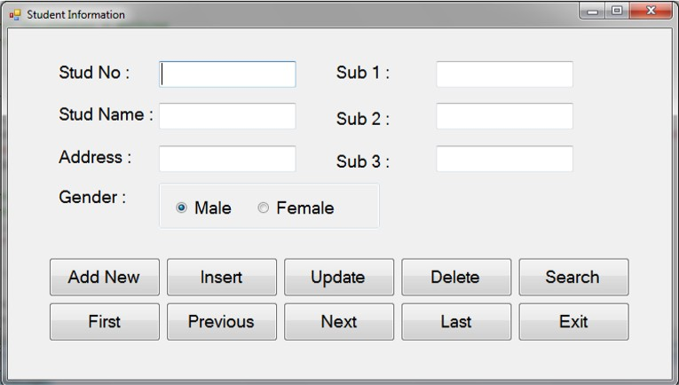  Design the form As shown below. Using Two Tables  Imports System.Data.SqlClient  Public ClAs sfrm61_J31_Gender  Dim con As New SqlConnection("Data Source=.\SQLEXPRESS;AttachDbFilename=E:\BCA\SEM4\US04CBCA22\sem4_vb_tutorial_Prg1to17\Tutorial\55_60\vbConnectionBAs edPrgs\student.mdf;Integrated Security=True;User Instance=True")  Dim cmd As SqlCommand  Dim da As SqlDataAdapter  Dim ds As DatAs et  Dim tbl As New DataTable()  Dim bm As BindingManagerBAs e  Dim str As String  Private Sub frm61_J31_Gender_Load(ByVal sender As System.Object, ByVal e As System.EventArgs) HandlesMyBAs e.Load  If (con.State = ConnectionState.Closed) Then  con.Open()  EndIf  str = "select s.stdno,name,addr,gender,m1,m2,m3 from std s,marks m where s.stdno=m.stdno "  cmd = NewSqlCommand(str, con)  da = NewSqlDataAdapter(cmd)  ds = NewDatAs et()  da.Fill(ds)  tbl = ds.Tables(0)  bm = Me.BindingContext(tbl)  txtStdNo.DataBindings.Add("text", tbl, "stdno")  txtName.DataBindings.Add("text", tbl, "name")  txtAddr.DataBindings.Add("text", tbl, "addr")  txtGender.DataBindings.Add("text", tbl, "gender")  txtM1.DataBindings.Add("text", tbl, "m1")  txtM2.DataBindings.Add("text", tbl, "m2")  txtM3.DataBindings.Add("text", tbl, "m3")  bindGender()  con.Close()  End Sub  Private Sub btnFirst_Click(ByVal sender As System.Object, ByVal e As System.EventArgs) Handles btnFirst.Click  bm.Position = 0  bindGender()  End Sub  Private Sub btnPrev_Click(ByVal sender As System.Object, ByVal e As System.EventArgs) Handles btnPrev.Click  bm.Position -= 1  bindGender()  End Sub  Private Sub btnNext_Click(ByVal sender As System.Object, ByVal e As System.EventArgs) Handles btnNext.Click  bm.Position += 1  bindGender()  End Sub  Private Sub btnLAs t_Click(ByVal sender As System.Object, ByVal e As System.EventArgs) Handles btnLAs t.Click  bm.Position = bm.Count - 1  bindGender()  End Sub  Private Sub btnNew_Click(ByVal sender As System.Object, ByVal e As System.EventArgs) Handles btnNew.Click  bm.AddNew()  txtStdNo.Focus()  btnInsert.Enabled = True  btnUpdate.Enabled = False  btnDelete.Enabled = False  btnSearch.Enabled = False  txtStdNo.Enabled = True  End Sub  Private Sub btnInsert_Click(ByVal sender As System.Object, ByVal e As System.EventArgs) Handles btnInsert.Click  If (con.State = ConnectionState.Closed) Then  con.Open()  EndIf  str = "insert into std values(@stdno,@name,@addr,@gender)"  cmd = NewSqlCommand(str, con)  cmd.Parameters.AddWithValue("@stdno", txtStdNo.Text)  cmd.Parameters.AddWithValue("@name", txtName.Text)  cmd.Parameters.AddWithValue("@addr", txtAddr.Text)  cmd.Parameters.AddWithValue("@gender", txtGender.Text)  cmd.ExecuteNonQuery()  'Insert in marks table  str = "insert into marks values(@stdno,@m1,@m2,@m3)"  cmd = NewSqlCommand(str, con)  cmd.Parameters.AddWithValue("@stdno", txtStdNo.Text)  cmd.Parameters.AddWithValue("@m1", txtM1.Text)  cmd.Parameters.AddWithValue("@m2", txtM2.Text)  cmd.Parameters.AddWithValue("@m3", txtM3.Text)  cmd.ExecuteNonQuery()  MsgBox("Student inserted successfully.")  btnInsert.Enabled = False  txtStdNo.Enabled = False  btnUpdate.Enabled = True  btnDelete.Enabled = True  btnSearch.Enabled = True  con.Close()  End Sub  Private Sub btnUpdate_Click(ByVal sender As System.Object, ByVal e As System.EventArgs) Handles btnUpdate.Click  If (con.State = ConnectionState.Closed) Then  con.Open()  EndIf  str = "update std set name=@name,addr=@addr,gender=@gender where stdno=@stdno"  cmd = NewSqlCommand(str, con)  cmd.Parameters.AddWithValue("@stdno", txtStdNo.Text)  cmd.Parameters.AddWithValue("@name", txtName.Text)  cmd.Parameters.AddWithValue("@addr", txtAddr.Text)  cmd.Parameters.AddWithValue("@gender", txtGender.Text)  cmd.ExecuteNonQuery()  str = "update marks set m1=@m1,m2=@m2,m3=@m3 where stdno=@stdno"  cmd = NewSqlCommand(str, con)  cmd.Parameters.AddWithValue("@stdno", txtStdNo.Text)  cmd.Parameters.AddWithValue("@m1", txtM1.Text)  cmd.Parameters.AddWithValue("@m2", txtM2.Text)  cmd.Parameters.AddWithValue("@m3", txtM3.Text)  cmd.ExecuteNonQuery()  bm.EndCurrentEdit()  MsgBox("Student updated successfully.")  con.Close()  End Sub  Private Sub btnDelete_Click(ByVal sender As System.Object, ByVal e As System.EventArgs) Handles btnDelete.Click  If (con.State = ConnectionState.Closed) Then  con.Open()  EndIf  str = "delete from std where stdno=@stdno"  cmd = NewSqlCommand(str, con)  cmd.Parameters.AddWithValue("@stdno", txtStdNo.Text)  cmd.ExecuteNonQuery()  str = "delete from marks where stdno=@stdno"  cmd = NewSqlCommand(str, con)  cmd.Parameters.AddWithValue("@stdno", txtStdNo.Text)  cmd.ExecuteNonQuery()  bm.RemoveAt(bm.Position)  MsgBox("Student deleted successfully.")  btnInsert.Enabled = False  con.Close()  End Sub  Private Sub btnSearch_Click(ByVal sender As System.Object, ByVal e As System.EventArgs) Handles btnSearch.Click  Dim dr As SqlDataReader  Dim stdNo As Integer  stdNo = Val(InputBox("Enter student number : "))  str = "select s.stdno,name,addr,gender,m1,m2,m3 from std s,marks m where s.stdno=m.stdno and s.stdno=@stdno "  cmd = NewSqlCommand(str, con)  cmd.Parameters.AddWithValue("@stdno", stdNo)  If (con.State = ConnectionState.Closed) Then  con.Open()  EndIf  dr = cmd.ExecuteReader()  If dr.HAs Rows Then  dr.Read()  txtStdNo.Text = dr("stdno")  txtName.Text = dr("name")  txtAddr.Text = dr("addr")  txtGender.Text = dr("gender")  txtM1.Text = dr("m1")  txtM2.Text = dr("m2")  txtM3.Text = dr("m3")  bindGender()  Else  MsgBox("Record for entered student no is not found.")  EndIf  con.Close()  End Sub  Private Sub btnExit_Click(ByVal sender As System.Object, ByVal e As System.EventArgs) Handles btnExit.Click  Me.Close()  End Sub  Private Sub bindGender()  If txtGender.Text = "m" Then  rdoMale.Checked = True  Else  rdoFemale.Checked = True  EndIf  End Sub  Private Sub rdoMale_CheckedChanged(ByVal sender As System.Object, ByVal e As System.EventArgs) Handles rdoMale.CheckedChanged, rdoFemale.CheckedChanged  If rdoMale.Checked Then  txtGender.Text = "m"  Else  txtGender.Text = "f"  EndIf  End Sub  End ClAs s

